ASSOCIATE DEGREE NURSING STUDENT HANDBOOK

2026 - 2027


TABLE OF CONTENTS

Professional Standards for Nursing Practice

American Nurses Association Standards | 4
Pre-Licensure Nursing Education Standards | 4
Quality and Safety Standards | 4
Interprofessional Collaboration Standards | 4
Regulatory and Legal Standards | 5
Student Responsibility | 5
Program Commitment | 5

Philosophical Framework

Philosophy, Mission, Vision and Values of the Associate Degree Nursing Program | 5
Conceptual Framework | 7
Definitions | 8
Timeline of the Annie Ruth Kelley Associate Degree Nursing Program | 9
Accreditation and Approval Status | 10
Annual Review of Philosophy, Conceptual Framework, and Outcomes | 10
General Purpose of the ADN Student Handbook | 11
Accountability | 11
Program Student Learning Outcomes | 11
General Education Learning Outcomes | 12
Conceptual Model | 13
Clinical Judgment Measurement Model | 14
Organizational Structure of the Nursing Department | 15

Student Policies

Appearance | 15
Conduct | 17
Performance | 17
Progression and Dismissal Policy | 19
Infectious Disease Policy | 21
Immunizations and Certifications | 21
Fees | 23
Testing | 23
Attendance | 24
Clinical Evaluation | 26
Learning Management System Policy | 30

Self-Service | 30
Online Learning Management System Statement | 30
Online Learning Management System Video Content and Access | 30
Points Policy | 30
ADA Statement | 31
Religious Observance Policy | 31
Honesty | 31
Social Media Policy | 32
Miscellaneous Information | 32

Curriculum Information

Readmission to the Nursing Program | 33
Criteria for Graduation | 37
Pinning | 37
Licensure | 37
Program of Study (General ADN track) | 37
Program of Study (LPN to ADN track) | 39

Appendices

Program Handbook Acknowledgment Form | i.
Remedial Skills Form | ii.
Unsafe Incident in the Clinical Setting Form | iii.
Clinical Probation Remediation Plan | iv.
Hepatitis B Declination Form | v.
SCC Medical Release Form | vi.
Simulation Guidelines | vii.
SCC Simulation Professional Integrity Agreement | viii.

Professional Standards for Nursing Practice
The Stanly Community College Annie Ruth Kelley Associate Degree Nursing (ADN) program is grounded in nationally recognized professional standards and competencies that guide curriculum design, instructional methods, student performance expectations, and evaluation of outcomes. These standards ensure that graduates are prepared to provide safe, evidence-based, patient-centered care as entry-level registered nurses and to successfully transition into professional practice.
Students enrolled in the Associate Degree Nursing (ADN) program are expected to demonstrate behaviors, clinical judgment, and professional conduct consistent with the following standards:

American Nurses Association (ANA) Standards
- American Nurses Association Scope and Standards of Practice
Defines the expectations for professional nursing practice, including assessment, diagnosis, outcomes identification, planning, implementation, and evaluation. These standards also include competencies related to ethics, communication, leadership, collaboration, and evidence-based practice.
- American Nurses Association
Establishes the ethical obligations and duties of every nurse, including the promotion of patient dignity, advocacy, accountability, and professional integrity.

Pre-Licensure Nursing Education Standards
- American Association of Colleges of Nursing
Provides a comprehensive framework for entry-level nursing education. The Essentials outline key domains including clinical judgment, person-centered care, population health, informatics, professionalism, and systems-based practice. These domains are integrated throughout the curriculum and used to evaluate student progression and readiness for practice.
- National Council of State Boards of Nursing
Serves as the framework for developing clinical judgment skills and aligns with the Next Generation NCLEX (NGN). Students are expected to demonstrate the ability to recognize and analyze cues, prioritize hypotheses, generate solutions, take appropriate action, and evaluate outcomes.

Quality and Safety Standards
- Quality and Safety Education for Nurses Competencies
Emphasize the knowledge, skills, and attitudes necessary to continuously improve the quality and safety of healthcare systems. These competencies include patient-centered care, teamwork and collaboration, evidence-based practice, quality improvement, safety, and informatics.

Interprofessional Collaboration Standards
- Interprofessional Education Collaborative Competencies
Promote effective teamwork across healthcare disciplines. Students are expected to demonstrate skills in communication, understanding of professional roles and responsibilities, teamwork, and shared ethical values.

Regulatory and Legal Standards
- North Carolina Board of Nursing Nurse Practice Act
Defines the legal scope of nursing practice within the state of North Carolina. Students must adhere to all applicable laws and regulations governing nursing practice and are held accountable for practicing within the appropriate scope for a student nurse.
Student Responsibility
Students are responsible for integrating these professional standards into all aspects of their academic and clinical performance. Failure to adhere to these standards may result in disciplinary action, up to and including dismissal from the program.
Program Commitment
The Nursing Program is committed to preparing graduates who meet established professional standards and are capable of delivering safe, competent, and compassionate care. Faculty utilize these standards to guide curriculum development, instructional strategies, and evaluation of student learning outcomes.

Philosophy of the Associate Degree Nursing Program

Mission
The Associate Degree Nursing (ADN) program supports the missions of both the North Carolina Community College System and Stanly Community College (SCC). The faculty is committed to providing accessible, high quality nursing education to meet the diverse and changing healthcare needs of the service areas and to promoting the development of qualified life-long learners prepared for the professional role of registered nurse at the entry level. The philosophy of the ADN Program is derived from statements about health, quality of life, achievement of potential, the individual, environment, health, nursing, the practice, and education of the Associate Degree Nurse. Within this mission, the goal of nursing faculty is to foster quality and caring nurses for the individual, families, significant persons, and the community. The aim is to facilitate optimum health, quality of life, and achievement of potential for the individual.

Vision
SCC’s ADN faculty envision program graduates providing safe, competent nursing care within the Registered Nurse scope of practice after successfully meeting the educational requirements to take and pass the National Council Licensure Examination (NCLEX-RN).

Values
Values of the Nursing Program are the same as SCC. These include student success, community, equity, innovation, and excellence.

The Associate Degree Nurse
The practice of nursing is directed toward meeting the healthcare needs of individuals throughout their lifespan. The graduate of the ADN program at SCC is prepared to meet the educational competencies defined by the National League for Nursing and the Nursing Practice Act of North Carolina. The model of competencies derived by the National League for Nursing is noted below for all levels of education, including the Associate Degree Nurse:

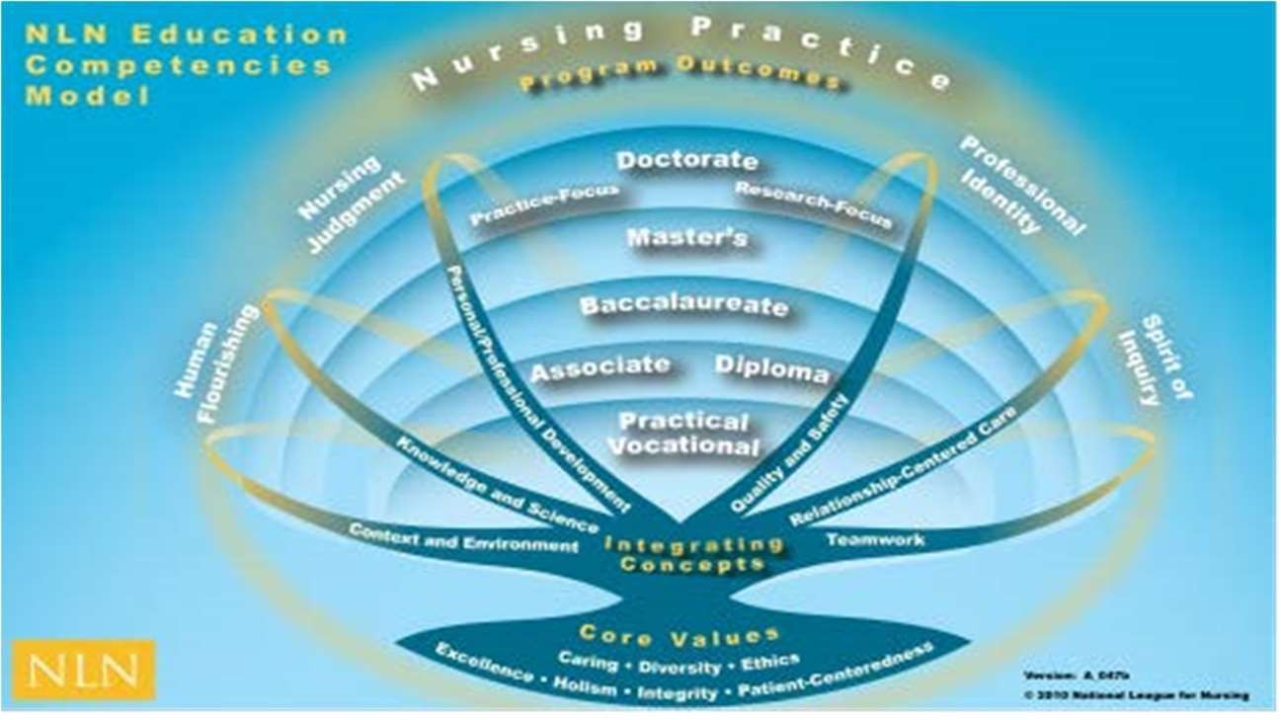

https://www.nln.org/docs/default-source/uploadedfiles/professional-development- programs/education-competencies-model-pdf.pdf

Associate Degree Nursing Education
Nursing education at the associate degree level, in the North Carolina Community College System, is a process that facilitates changes in behavior, the acquisition of knowledge, skills, and attitudes necessary to function in the role of the entry-level nurse. The curriculum is conceptually based and founded on principles of culturally competent adult and collaborative learning. It incorporates evidence-based nursing theory and practice, general education, and the sciences in an environment conducive to learning.
The ADN Program at SCC provides an education that is flexible, progressive, and sensitive to the changing needs of the individual, significant support person(s), and community. Through these educational experiences, students will have opportunities to develop critical thinking and problem- solving skills, which are crucial components of clinical judgement, and can be applied in real-world commitments. SCC’s ADN program integrates three nursing roles into educational experiences, including provider of care, manager of care, and member within the discipline.
The responsibility of the faculty of SCC’s ADN Program is to facilitate the student’s understanding and ability to meet the competencies for nursing practice through the design and evaluation of learning experiences. The nursing student is responsible for actively participating in learning experiences and developing the knowledge, skills, and attitudes necessary to provide quality client-centered nursing care. It is the belief of the nursing faculty that education is an interactive exchange between instructor and student.

Conceptual Framework
The conceptual model provides a mental scaffold or framework. The primary framework contains content related to the individual, the healthcare system, and nursing. The domains of the individual, the healthcare system, and nursing provide the conceptual framework guiding the associate degree nursing curriculum. Concepts are organized within each of these domains, and learning occurs from simple to complex. Supporting structures to the curriculum are related to client care and include quality of life, achievement of potential, and health.
The student is at the center of the conceptual model. The environment, which is noted as all- encompassing to the model, affects all structures of the model. Additional fundamental parts of the curriculum that are integrated throughout the program are the nursing process, communication, documentation, teaching/learning, caring, evidence-based practice, and cultural diversity.

Primary framework definitions and supporting structure definitions are found below:

Individual
The faculty of SCC believe that each individual is a complex, multidimensional, unique, and significant being possessing inherent value and worth, and a member of a family, community, and culturally diverse society. All individuals have dynamic bio-physical, psychological, sociocultural, spiritual, and developmental needs that contribute to health, quality of life, and achievement of potential.
Adaptation to the environment requires the individual to change throughout the lifespan. Each individual has a right to healthcare. In addition, each individual should receive information that will enable them to participate actively in their care to achieve the highest level of wellness possible. All individuals should be cared for, respected, nurtured, understood, and assisted. In order to provide

care, act as a member within the discipline, and manage care, nurses must keep the individual at the center of all nursing actions.

Healthcare System
The healthcare system encompasses a myriad of entities. These entities provide specific services related to the care of the individual. Services are aimed at promoting health, assuring quality of life, and achieving one’s potential.

Nursing
Nursing is not only a discipline of science, but also a life-long learning process. The process integrates knowledge and skills derived from biological, sociological, and behavioral sciences and information technology to deliver client-centered, culturally competent, holistic care. Through caring, empathy, ethics, and the development of a therapeutic relationship with the individual and significant support person(s), the nurse integrates the art of nursing with the scientific foundation for nursing practice utilizing the nursing process. By incorporating documented best practice, the nurse functions autonomously as manager of care and provider of care, and functions collaboratively as a member with the interdisciplinary team to promote health, quality of life, and achievement of potential.

Environment
The individual, as well as the student within this model, is in constant interaction with a changing environment that consists of both internal and external forces that varies throughout the lifespan and has the potential to cause stress in the individual/student. The goal for the individual/student is to utilize innate and learned coping mechanisms to adapt to these stressors.

Health
Health is a dynamic, ever-changing state of mental, physical, and spiritual well-being, which exists on a continuum from optimal wellness to illness and ending in death. The individual’s needs for healthcare are determined by his/her position on the continuum. Each individual’s health is based on his/her cultural perceptions and beliefs of health and illness and the ability to adapt to internal and external environmental forces. The individual is responsible for and capable of identifying, learning, and practicing health behaviors that can promote wellness, prevent illness, restore or maintain wellness, or achieve a dignified death.

Quality of Life
Quality of life, as it pertains to healthcare, is multifaceted and multidimensional. Standard indicators of the quality of life include not only wealth and employment, but also one’s environment, physical and mental state, education, recreation and leisure time, spiritual beliefs, and social belonging.

Achievement of Potential
Achievement of potential is the individual’s growth toward attaining one’s utmost ability and quality of life. It is based on the individual’s choices, perceptions, personal goals, life experiences, and holistic health. Cultural preferences are considered as they relate to one’s personal beliefs of achievement.

Resources reviewed prior to development/revision of the program philosophy: https://nap.nationalacademies.org/catalog/25982/the-future-of-nursing-2020-2030-charting-a-path-to https://www.nln.org/education/nursing-education-competencies
https://www.ncsbn.org/public-files/2023_RN_Test%20Plan_English_FINAL.pdf https://www.ncsbn.org/research-item/ncsbn-regulatory-guidelines-and-evidencebased-quality-indicators- for-nursing-education-programs

Timeline of the Annie Ruth Kelley Associate Degree Nursing Program
SCC’s ADN Program is one of 58 ADN programs in North Carolina, and one of 56 based at a community college. SCC began by offering the Licensed Practical Nurse (LPN) curriculum in 1973 and in 1974 graduated its first class of LPNs. SCC graduated a total of 119 LPNs before adding its two-year ADN program in 1985. The first graduates of the new two-year ADN program were awarded credentials in 1986. In 1999, SCC began operating a satellite ADN program on the Old Charlotte Highway campus of South Piedmont Community College. This arrangement continued until 2006 when the relationship dissolved. In 2005, the college’s ADN program was named after Ms. Annie Ruth Kelley in recognition of her part in the growth and success of the program. Currently, the nursing program of SCC is housed at the Crutchfield Education Center (CEC) in Locust, NC. Prior to the move to CEC in fall of 2013, the nursing program utilized two campuses, the main campus in Albemarle and the Locust CEC site fifteen miles apart. In 2024, SCC reestablished the LPN program.

In 2010, SCC’s nursing faculty began the North Carolina Curriculum Improvement Project (NCCIP). Since the creation of a conceptual based learning approach to nursing, the curriculum has undergone complete overhaul and is continuously evaluated for areas of improvement. Spring of 2012 introduced the first graduating class to take the NCLEX-RN based on conceptual learning implemented in 2010.

The SCC Annie Ruth Kelley ADN Program is one that thrives on innovation. In addition to the delivery of course content mentioned above, the Simulation Hospital is utilized as a learning experience for students with faculty using best practices set forth by The International Nursing Association for Clinical Simulation and Learning (INACSL). Simulated clinical learning is a non-threatening environment for students to practice critical thinking without the risk of patient harm. Efforts have been made to enhance real-life clinical experiences by incorporating interprofessional simulation scenarios. Spring 2015 began the initial introduction of simulated nursing care with other disciplines (Respiratory Therapy, Radiology, Pharmacy Technicians, Emergency Medical Services, and Medical Assistants). More interprofessional care experiences have taken place although briefly interrupted by the pandemic.

Faculty commitment in our program is evident as faculty members hold pre-semester meetings to plan, mid-semester meetings (undocumented) to evaluate student progress, and post-semester meetings to evaluate outcomes. 2014 marked the first curriculum review and has since been an annual event of faculty to identify strengths and weaknesses for program improvements. Our program endpoint involves each student behaving as a safe, culturally competent, entry-level nurse after passing the NCLEX-RN. This idea of providing the public with safe, competent nurses is supported by our governing body which gives us approval status and is agreed upon by all faculty employed within the nursing program.
Therefore, each program student learning outcome was meticulously developed, as well as each course

specific student learning outcome developed to show progression toward this culmination. Review of data, such as tests, test questions, test blueprints, clinical experiences, rubrics, and other anecdotal documents used throughout the curriculum provide data to convey if the course specific student learning outcomes are met. This data further allows faculty to determine if specific areas need to be altered or if the specified criteria supports the intended outcomes. Student retention is continuously evaluated with implementation of retention efforts.

2018 marked the use of Quality and Safety Education for Nursing (QSEN) standards throughout the curriculum. Textbooks, simulation scenarios, and other methods of student learning and evaluation cultivate a nursing culture of knowledge, skills, and attitudes.

The SCC ADN program is provided in a blended composition. The nursing (NUR) courses are delivered using the Interactive Video Room (IVR), a video conferencing system where an instructor can communicate to those students in seated class and communicate simultaneously with online students viewing the classroom discussion livestream if chosen. This communication is then recorded and flipped into video files for students to watch in an asynchronous fashion. Additional communication takes place between all students regarding questions related to course content via asynchronous discussion forums and email exchanges through the learning management system portal. Students however are encouraged to attend class in person as recording of lectures may be unavailable during times of unanticipated technical difficulty.

The changes of the program over the years, substantial or minute, continue to support the mission of the college to enhance the economic, social, and cultural life of the communities we serve by providing learner-centered environments that encourage access, success, and completion. Moreover, the mission of the nursing program is apparent; it provides accessible, high-quality nursing education to meet the diverse and changing healthcare needs of the service area and promotes the development of qualified students prepared for the professional role of registered nurse at the entry level.

Accreditation and Approval Status
The Annie Ruth Kelley ADN Program is part of SCC, which is Southern Association of Colleges and Schools (SACS) accredited.

The program has full approval granted by the North Carolina Board of Nursing.

The Stanly Community College Associate Degree in Nursing program is accredited by the National League for Nursing Commission for Nursing Education Accreditation (NLN CNEA) located at 2600 Virginia Avenue, NW, Washington, DC 20032, 202-909-2525.

Annual Review of Philosophy, Conceptual Framework, and Outcomes

The Annie Ruth Kelley ADN Program faculty at SCC accepts the responsibility to annually review and revise, as necessary, the statement of philosophy, outcomes, and organizing framework. Reviews and revisions by faculty address the current needs of both healthcare providers and consumers ensuring close

congruency with the college mission, goals, and value statements. Faculty meetings reflect these discussions, which are available for review by evaluators of the program.

General Purpose of the ADN Student Handbook
The purpose of this handbook is to provide the ADN student with relevant information regarding SCC’s ADN Program. Policies and procedures specific to the ADN program are found within this section of the handbook. These policies and procedures have been developed by the nursing faculty and are updated periodically. Students have access to the ADN Handbook via all NUR courses and the SCC website.
Immediate revisions are conveyed to students via email or course announcements.

Accountability
The student shall read the ADN Student Handbook, the course syllabi, and other official college publications. Students will not be excused from any regulation, requirement, or deadline set forth in these publications.

Program Student Learning Outcomes
Upon completion of the Associate Degree Nursing Program, the graduate will:

- Establish safe, professional nursing behaviors including accountability for entry level nursing competence as demonstrated by a passing score* on the NCLEX-RN licensure exam as delineated by the rules and regulations of the North Carolina Board of Nursing.
*=NCLEX-RN does not award numerical scores. Reports only include pass or fail.

- Communicate with individuals, significant support person(s), and members of the interdisciplinary healthcare team as demonstrated by a grade of “pass” on the summative clinical evaluation tool described under the nursing domain.

- Formulate holistic assessments to identify the needs of the individual in order to provide culturally competent client-centered care as demonstrated by a grade of
“satisfactory” on the complex patient comprehensive assessment on the clinical prep tool.

- Utilize healthcare informatics to apply research to practice for evidence-based practice, clinical judgments, and management decisions as demonstrated by a score of “satisfactory” on the evidence-based practice project completed in the capstone course.

- Create nursing plans of care for clients across the lifespan as demonstrated by cognitive proficiency on the nursing caremap in the clinical setting.

- Incorporate teaching and learning principles into nursing practice as demonstrated by completing a capstone teaching project with a passing score of 80% or above.

- Manage healthcare for clients by utilizing cost-effective nursing strategies, quality improvement processes, and legal/ethical awareness to promote quality outcomes as demonstrated by a

“passing” graded clinical performance to prove cognitive and behavioral proficiency of the healthcare domain as described on the clinical summary.

Course Student Learning Outcomes
Course student learning outcomes are found within course syllabi.

General Education Student Learning Outcomes
General Education Learning Outcomes | Course Measurement (Generally Speaking, Specific measurements found within NUR courses)
1 Demonstrate effective communication skills. | 1 The student demonstrates effective communication skills through managing the care of the client with multidisciplinary team members in the clinical setting, as well as among  classmates through oral presentations.
2 Apply basic mathematical concepts and skills. | 2 The student applies basic mathematical concepts and skills in pharmacological application in the classroom and clinical setting.
3 Demonstrate basic computer skills necessary to function in a technological world. | 3 The student demonstrates basic computer skills through online charting in the clinical setting, use of e-books, use of virtual simulation scenarios, and using Canvas for  online instruction.
4 Demonstrate problem-solving skills through thinking and reasoning skills. | 4 The student demonstrates problem solving and critical thinking skills in the basic and complex care of clients. These skills are further evaluated through common techniques within the curriculum (i.e., Simulation,  NCLEX-RN style questioning).

Stanly Community College Conceptual Model

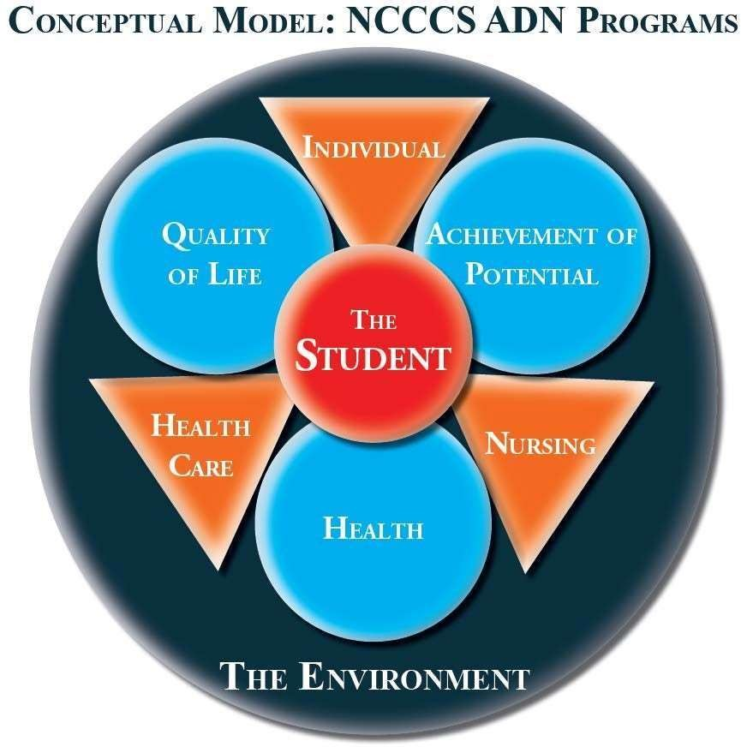

The Clinical Judgement Measurement Model (CJMM) established by the National Council of State Board of Nursing was developed as a framework for the valid measurement of clinical judgement and decision making. The Annie Ruth Kelley Associate Degree Nursing faculty believe that the safe, entry- level nurse should be able to utilize the nursing process to help them recognize cues, form hypotheses, prioritize actions, and evaluate actions while providing safe, culturally appropriate nursing care to all prospective clients regardless of the environment.

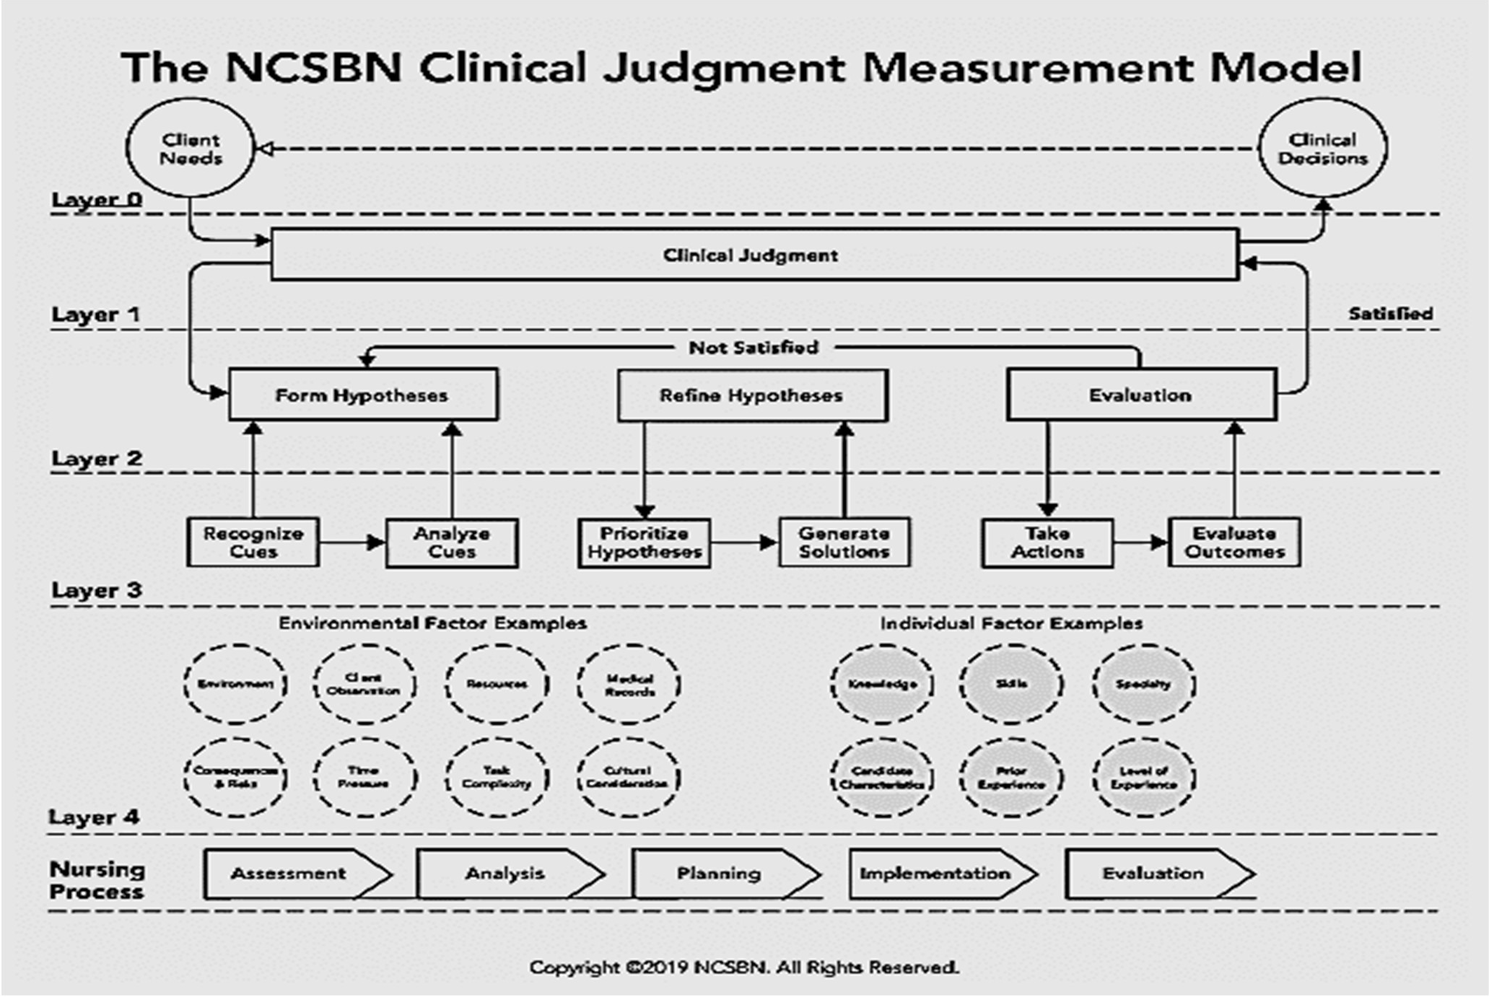

Organizational Structure

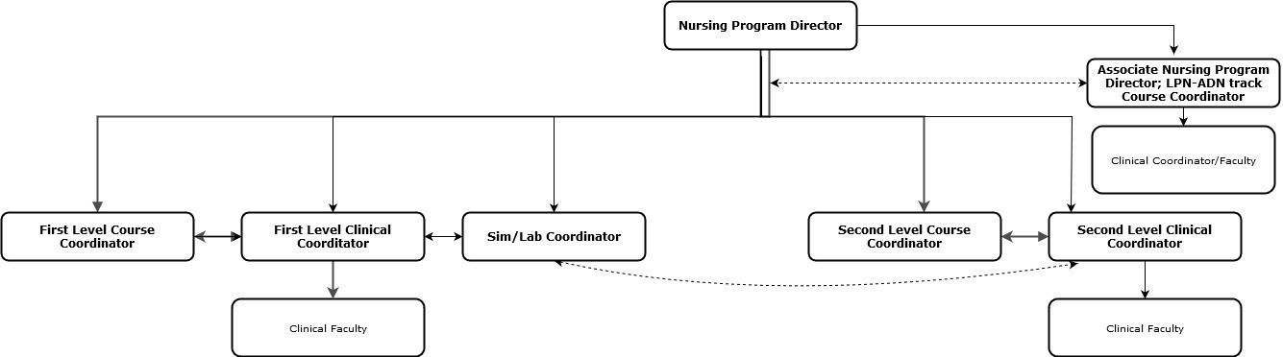

The nursing department organization is linear on paper; however, all nursing faculty collaborate to meet the needs of the program and students. All nursing faculty report to the Nursing Program Director. In the absence of the Program Director, the Associate Director oversees processes.
First level in the general track includes a Course Coordinator, Clinical Coordinator, and Lab/Simulation Coordinator. Second level includes a Course Coordinator and Clinical Coordinator. The second level Clinical Coordinator works with the Lab/Simulation Coordinator to meet student learning objectives.
Part-time clinical faculty report directly to their respective clinical coordinators.
Students are expected to utilize this chain-of-command approach in communications with nursing faculty.

Student Policies (in addition to Health Sciences Handbook)

Student Appearance and Professional Attire

Students enrolled in the Nursing Program are expected to maintain a professional appearance that reflects the standards of the nursing profession and promotes patient safety, infection control, and public trust. Students must comply with the following requirements in all clinical, simulation and lab settings:
    - General Appearance: Personal hygiene must be maintained at all times. Attire must be clean, wrinkle-free, and in accordance with the program dress code and clinical agency policies. Students must present a neat, professional image consistent with the role of the student nurse.
    - Hair: Hair must be clean, well-groomed, and secured up and off the shoulders. Hairstyles must not interfere with patient care or the use of personal protective equipment. Hair color must be of a natural tone.
    - Nails: Nails must be natural (no artificial nails, acrylics, overlays or dip powder. Nail polish, if permitted by the clinical agency, must be neutral and free of chips.
    - Jewelry and Accessories: Jewelry must be kept to a minimum to reduce the risk of injury and infection. Permitted jewelry includes one plain wedding band and one pair of small stud earrings (one per ear). All other jewelry is prohibited, including bracelets, necklaces (unless required for medical alert), and visible body piercings.
    - Tattoos and Piercings: All tattoos must be fully covered during clinical and lab experiences. No visible body piercings are permitted other than one pair of earrings as described above. This includes, but is not limited to, nose, tongue, eyebrow, lip or facial piercings.
    - Makeup and Fragrance: Makeup must be minimal and natural in appearance. False eyelashes or excessive eyelash extensions are not permitted. Fragrances, perfumes and scented products must be avoided due to patient sensitivity and allergies.
    - The ADN student uniform includes a galaxy blue top with SCC emblem and black pants or black knee-length skirt. Black shirts without adornment may be worn under uniform top. Clean, closed, non-porous, black shoes, and plain black socks with pants or black hose/tights with knee-length skirt.
    - Anything worn outside of the above-described uniform is considered a breach of student policy and the student will be sent home. Head covering is not allowed, unless for religious purposes, which must be approved by the Clinical Coordinator.
    - A watch with second hand, bandage scissors, stethoscope, ECG calipers and penlight are needed. Note: ECG calipers and penlight are part of the nursing bag purchased through the uniform vendor. Smart watches are not allowed.
    - A clinical notebook will be necessary to create and maintain throughout the program to show clinical progression. Any ring-binder will work and will be purchased by the student at a retailer of choice.
    - A lab/warm up coat may be worn. Lab/warm coats should be black, clean and made of wrinkle free fabric, not sweatshirt material. The lab/warm up coats must include the SCC ADN logo.
    - No cell phones are permitted in patient care areas.
    - Some clinical agencies may have additional requirements regarding dress, appearance, etc. which shall be upheld by the visiting students. Students must abide by all clinical and facility specific policies.

Anyone not complying with these policies related to appearance will be sent home. This will be considered a clinical absence (see Clinical Attendance policy).

- Conduct
Conduct viewed as disruptive will not be tolerated within class or clinical – See Student Code of Conduct Policy located in the policy section at:
https://www.stanly.edu/academics/policies-rules/policies/index.html

  - Classroom:
    - Drinks in the classroom must have a screw-top lid.
    - No food or drink is allowed in the nursing lab or Simulation Hospital at any time.

  - Clinical:
    - Knock before entering closed doors in the hospital. Wait for permission to enter before entering.
    - Smoking will not be allowed in clinical areas. This includes the use of vapes and e-cigarettes.
    - Breaks and lunch will be arranged by the clinical instructor.
    - Information regarding clients and fellow students is confidential and can only be discussed in a private area for the purpose of learning. Any break of this rule of confidentiality will result in remediation and possible dismissal from the program and possible prosecution (See HIPAA regulations). The student is required to sign a confidentiality form stating understanding and willingness to abide by the policy.
    - Obscene or profane language will not be tolerated.
    - Students must remain within the clinical facility during meals and breaks.
    - Students must notify the instructor and primary nurse before leaving the floor. Failure to comply may result in an unsafe incident related to abandonment of client care.

Performance
  - Performance Standards for Students in the clinical and classroom settings:
    - Critical Thinking:
Nursing students shall possess critical thinking ability sufficient for clinical judgment. Example: Students must be able to identify cause-effect relationships in clinical situations; develop or participate in development of nursing care plans/concept maps and or care maps.
    - Ethical Behavior and Cultural Competence:
Nursing students will provide services with respect for human dignity and the uniqueness of the client unrestricted by consideration of social or economic status, personal attributes, or the nature of health problems. Example: Students will care for clients assigned regardless of race, religion, or diagnosis
    - Legal Behavior:
Nursing students will provide care within the scope of practice as stated in the NC Nursing Practice Act. Example: Students in the nursing program will learn to assess the patient’s physical and mental health and report and document according to those findings.

    - Interpersonal Skills:
Nursing students shall possess interpersonal abilities sufficient to interact with individuals, families, groups, etc. from a variety of psychosocial cultural backgrounds. Example: Students shall establish rapport with clients and health care team members.
    - Communication Skills:
Nursing students shall possess communication abilities sufficient for verbal and nonverbal interaction with others. Example: Students shall be able to explain treatment procedures to clients/family, document client responses, and report to others responsible in client care.
    - Mobility:
Nursing students shall possess physical abilities sufficient to move from room to room and maneuver in small spaces, stand and walk for extensive periods of time.
Example: Students will be able to move around in the client’s room and administer CPR.
    - Motor Skills:
Nursing students shall possess gross and fine motor skills sufficient to provide safe and effective nursing care. Example: Students shall be able to calibrate equipment, position clients, administer injections, insert catheters, etc.
    - Hearing Skills:
Nursing students shall possess auditory ability sufficient to monitor health needs and collect data. Example: Students shall be able to hear alarms, listen to heart and breath sounds, and hear a cry for help.
    - Visual Skills:
Nursing students shall possess visual ability sufficient for observation and data collection. Example: Students shall be able to observe color of skin and read scale on a syringe.
    - Tactile Skills:
Nursing students shall possess tactile ability sufficient for data collection. Example: Students shall be able to detect pulsation and feel skin temperature.
    - Weight-Bearing:
Nursing students shall possess the ability to lift and manipulate/move at least 40-50 pounds. Example: Students shall be able to move equipment and position patients.
  - Emotional Health
The emotional health of each student is evaluated by a primary care provider using the required medical form completed prior to starting the program. When emotional
conditions prevent satisfactory classroom or safe clinical performance, the instructor will dismiss the student from class or clinical. The Program Director, in collaboration with the Associate VP of the School of Health Sciences & Public Services and the Executive Vice President can immediately dismiss the student from the ADN program. (Reference SCC Catalog – Student Code of Conduct)
  - General performance related to clinical settings and classroom/lab settings:
    - Instructors will not be responsible for missed classes or lost materials by students. It is the student’s responsibility to seek additional help as needed.
    - Students are expected to complete clinical assignments within the allotted time.
    - Students are expected to immediately notify the instructor and/or team leader of changes in client’s condition requiring immediate intervention.
    - Evaluations regarding student clinical performance will be documented with each clinical experience using a weekly clinical summary. Both student and instructor will have an opportunity to record comments and to communicate to each other both effective and ineffective behaviors on the weekly clinical summary. Based on the documentation within this record, a final grade of pass or fail will be assigned on the end of course clinical summary. The instructor is to evaluate the student’s clinical performance, identify strengths and weaknesses and make remediation plans, as necessary. See Clinical Evaluation policy.
    - Students will be held accountable for retaining and refining skills and knowledge obtained in previous courses as they proceed through the program. Failure to do so will result in remediation, and possible dismissal from the program if remediation is not satisfactory.
    - All medications are to be reviewed by an instructor prior to administration.
NOTE: Any medication requiring signed consents prior to administration, the RN will get the consent signed and then the student can give the medication with the RN.
** Drugs that are NOT given by nursing students: **

      - IV antineoplastic medications (Chemotherapeutics)
      - Whole blood and blood products (packed cells, plasma, platelets, and Rhogam)
      - Radioactive substances
      - Medications during CPR
      - Thrombolytics (i.e., TPA)
      - “Yellow Bin” medications

- Progression and Dismissal Policies:
  - For the student to progress in the nursing program, a grade of C or higher must be achieved for all courses listed within the nursing program of study. All course work taken at SCC must have a 2.0 GPA or higher.
Students earning less than a C in a nursing course and/or any other course within the nursing program of study will be withdrawn from the nursing program automatically. If a student receives below a C (below 80) in the theory component or fails in the clinical component of nursing courses, a grade of F will be submitted for the overall grade for the course.
Please be aware that Satisfactory and Unsatisfactory assignments of each NUR course are linked to the end-of-course clinical summary, which is different from an
unsatisfactory issued on the weekly clinical summary. An unsatisfactory evaluation on the end-of-course clinical summary will result in a failing grade for the course.
Students taking general education courses from another college will be required to present proof of course completion to progress. Students will not be allowed to register without the transcript information. Progression depends on maintaining general education course grades and GPA.
Progression throughout NUR 112 and 212: NUR 117 is a 16-week course for the general track. Students withdrawing from this course must withdraw from NUR 112/212 at the same time.
The grading scale for all NUR courses is as follows:
A= 94 - 100
B= 87 - 93
C= 80 - 86
F = a score of less than 80 in theory or fails the clinical evaluation

ROUNDING POLICY: All grades are calculated to the nearest hundredth throughout the entire semester. The final course grade is calculated to the nearest whole number with 0.49 or less rounded down to the nearest whole number, and 0.5 or more rounded up to the nearest whole number.

  - Students are assigned Success Coaches for advising related to the nursing curriculum. Success Coaches will assess student needs throughout the program. If problems arise at any time during the program, the student is responsible for scheduling an appointment with a nursing Success Coach, Counselor, or the Learning Specialist.

  - In the event a student’s physical or mental health interferes with the student’s academic and/or clinical performance, the nursing faculty may require the student to submit written verification of current health from an appropriate health care provider (i.e., physician, nurse practitioner, psychiatrist, or psychologist). Upon review of the professional statement of health submitted by the student, the Program Director of Nursing, the Associate Vice President of the School of Health Sciences & Public Services, and the Dean of Student Outreach & Support will determine if the student may continue in the program. The Dean of Student Outreach & Support or AVP of the School of Health Sciences & Public Services will notify the student in writing of the decision.

  - In the event that a student’s behavior is not consistent with sound nursing practices and/or safety essential to nursing, the faculty, clinical facilitators, or the Program Director of Nursing have the authority to temporarily remove the student from the clinical, class, or lab setting immediately with the loss of clinical hours if related to clinical removal. If the faculty or the Program Director determines that the student has demonstrated behavior conflicting with sound medical care practices or safety, recommendation will be made to withdraw the student from the class or program to the Associate Vice President of Health Sciences & Public Services. The Associate
Vice President of Health Sciences & Public Services will notify the student in writing of this recommendation.

  - Students unable to complete the clinical portion of his or her training will be unable to progress in the program.

Infectious Disease Policy:
Because of the nature of the health care profession, students participating in required clinical education experiences will find themselves at risk for exposure to infectious diseases. The risk cannot be eliminated. However, it can be minimized by careful and consistent technique and the implementation of standard precautions in the care of all health care consumers.
Students will be instructed in standard precautions. “Standard precautions” (i.e., gloves and safety glasses, gowns, handwashing, and masks where appropriate) will be implemented in the care of all clients. Because of the nature of the student-client relationship, the client must also be protected from a student caregiver who may transmit infectious diseases.

The following information deals with the SCC nursing program policy for handling infectious disease:
- Exposure includes percutaneous injury with a contaminated sharp object (needle, lancet, broken slide, etc.) and exposure of mucous membranes or open skin lesions to blood or body fluid of clients.
- It will be the student’s responsibility to notify the clinical instructor immediately when an incident has occurred. The clinical instructor will notify the Clinical Coordinator and follow the exposure policies of the clinical agency and the college. (see student occupational exposure incident report - appendix VI in Health Sciences Student Handbook)
- Students will be responsible for health care expenses incurred in treatment following exposure to infectious diseases. It is advised that all students carry health insurance.

Immunizations and Certifications:
  - Immunizations required for clinical placement are:
MMR | You must submit A OR B:  - 2 doses of the MMR vaccine. After the first dose you will be compliant for 30 days to allow time to receive the second dose.  - Positive titers for measles, mumps, and rubella. ** A positive antibody titer for all 3 components (lab report or physician verification of results required). Documentation must include the numerical result of the titer and indicate that the results are "positive", "reactive", "immune", etc. If titer is  negative or equivocal, a new alert will be created for you to provide one booster shot.
Varicella | You must submit A OR B:  - 2 doses of the varicella vaccine. After the first dose you will be compliant for 30 days to allow time to receive the second dose.  - Positive varicella titer. Documentation must include the numerical result of the titer and indicate that the results are "positive," "reactive," "immune," "antibody detected," etc. If your series is in  process, submit where you are in the series, and a new alert will be created for you to complete the

process. If your titer was negative or equivocal, new alerts will be created for you to repeat the series.
History of the disease is NOT sufficient proof of immunity.
Hep B | You must submit A OR B OR C or D:  - 3 doses of the hepatitis B vaccine. After the first dose you will be compliant for 1 month to allow time to receive the second dose. After the second dose you will be compliant for 5 months to allow time to receive the third dose.  - Positive hepatitis B titer. A positive antibody titer (lab report or physician verification of results required). Documentation must include the numerical result of the titer and indicate that the results are "positive," "reactive," "immune," etc.  - Heplisav-B 2-dose series at least 4 weeks apart  - Declination form (see Appendix v)  If titer is negative or equivocal, new alerts will be created for you to repeat the vaccination series.
TB | Initially, you must submit the following:  - Either a 2-step PPD (2 PPD's dated 1-3 weeks apart) or an IGRA (QuantiFERON or T-Spot) from within the last year.  - Baseline Individual TB Risk Assessment Form including TB symptom evaluation found at the following site: https://www.cdc.gov/tb/topic/testing/healthcareworkers.htm  If you test positive for tuberculin exposure, you must submit a negative chest x-ray from within the last 5 years and the below Annual Tuberculosis Risk Assessment and Attestation form in both your first year and every year thereafter.  Subsequently, students will complete the Annual Tuberculosis Risk Assessment and Attestation Form: https://www.wakeahec.org/pdf/CCEP/TB_Attestation_11_2020_FILLABLE.pdf
Tdap | One-time dose of Tdap as soon as possible if individual has not received a Tdap previously (regardless  of when the last dosed of Td was received). Tdap booster every 10 years thereafter.
Flu | You must submit a flu shot for the current season.  Your flu shot must be received no earlier than 8/1 to be accepted for the current flu season.  This category is not tracked between 4/1 and 10/31.  Please include:  -Typeset/Stamped name of provider (Not required on Institution-specific forms)  - Student name  - Service/Immunization name  - Service date  - Provider signature/stamp if document has a signature Field
CPR | You must submit your current American Heart Association Basic Life Support CPR Card.  *Must be AHA for the Healthcare Provider, will not accept Heart Saver, or other alternatives
Student Medical Form | You must submit the Student Medical Form including the physical completed within the last year and signed by a physician, physician's assistant, or nurse practitioner.
Paperwork (medical form, immunizations/titers, clinical site required paperwork, CPR certification, background checks, urine drug screening and Handbook paperwork) are housed in electronic format using an online tracking vendor that is username and password protected. Refer to the compliance tracking system for further details.
Information is shared with clinical sites using this online format after student consent is obtained.

  - Certifications required for admission purposes

General ADN track students are required to have NAI certification and be listed on the NC Department of Health and Human Services Healthcare Personnel by the date specified in their admissions letter. Applicants must submit a certificate of satisfactory completion from a DHSR (Division of Health Service Regulation) approved Nurse Assistant, Level I program, and current unrestricted certification in Nurse Assistant, Level I as listed on the NC Nurse Aide registry (http://www.ncnar.org). If an applicant is currently employed as a Nurse Assistant level I but cannot produce a certificate from a DHSR (Division of Health Service Regulation) approved Nurse Assistant, Level I program, documentation from the applicant’s current employer that the applicant has spent at least 240 hours providing patient care at the bedside may be submitted to the Director of Admissions for consideration.
NOTE: Upon successful completion of NUR 112, students will be offered the option to obtain CNAII certification through the NC Board of Nursing. To acquire this certification, the student must hold an active CNAI certification and maintain it for CNAII certification.
LPN-ADN track students are required to submit a current, unrestricted LPN license per the NCBON requirements. The LPN license must be a North Carolina or compact/multi-state license. Work experience is not required but is recommended by the nursing faculty.

Fees:
Tuition for the nursing program is based on the number of credit hours taken within a given semester. The following link explains tuition and other charges in detail. Refer to the website for tuition costs: https://www.stanly.edu/financial-aid/cost-attendancebudget.html

Required textbooks vary in price from year to year and vary between the two tracks (general track and LPN-ADN track). Most books, required computer testing, and supplies are purchased at the beginning of the program (approximately $2000 –general track; $500 – LPN-ADN track). Nursing kit and uniforms are approximately $300. Miscellaneous (i.e., immunizations, drug screening and background check) are approximately $300. In the capstone course, NUR 213 or NUR 223, a fee for Hurst NCLEX review course will be applied at the time of registration.

Testing:
  - The ADN program utilizes computerized testing. Refer to your course syllabus for specific testing methodologies/policies.

  - Other computer-based software applications are utilized within SCC nursing program (i.e., PrepU, vSIM, DocuCare). These are at the cost to the student. PrepU uses adaptive NCLEX-style questioning to simulate the NCLEX-RN. vSIM is a computerized virtual patient simulation where simulations are carried out based on the National League of Nursing Scenarios. DocuCare provides a computerized documentation system to emulate technology common in the clinical setting. StatRef! and Board Vitals, free services with

varying resources, are offered by the NC Community College System and are accessible through SCC’s library resources.

  - Testing Procedures:
    - Students must be on time for scheduled exams. Refer to attendance for scheduled exams below.
    - A proctor will be available during testing periods to answer questions regarding typographical errors. No other questions will be answered during a test.
    - Before the test, all items will be stored at the front of the classroom except for pencils, clean scrap paper/card stock when necessary, and a calculator issued by the proctor.
    - In the event the student needs to use the restroom while testing, a proctor will escort the student, or a hall pass may be utilized.
    - All group test papers must be returned after the testing period. Tests are not allowed to leave the classroom.
    - Students are not allowed to wear hats into the classroom on scheduled test days.
    - Faculty believes learning should be on-going and all-inclusive. Therefore, faculty reserve the right to include content from previous semesters on tests.
    - Canvas resources will be hidden from viewing at the beginning of each testing period. This includes access to notes, videos, lectures, etc. for the material being tested on. Material will be re-opened after test review or after all tests are completed or at the discretion of the instructors.
    - Smart watches and/or AirPods are not allowed to be worn during tests.
    - Other testing procedures are specific to nursing courses. Any additional testing procedures are found within nursing course syllabi.
    - If a violation of the testing policy occurs the SCC Academic Dishonesty Policy will be followed.
    - Students are not permitted to retake exams. To participate in group testing, students must be physically present in the classroom at the time group testing begins. Students with approved accommodations who wish to participate in group testing must report directly to the classroom and wait until the group testing session begins.

Attendance:
  - Scheduled Exams:
    - Absence for scheduled exam:
      - In the event a student needs to be absent for a scheduled exam, the student will notify the instructor prior to the testing period by phone or email. The student will take the alternate exam on a day at the instructor’s discretion or receive a zero for that exam. Time and date of the exam are to be decided by the instructor and arranged by the student with testing center hours of operation. Students are expected to be on their honor not to discuss the test with classmates before taking it. Instructors reserve the right to use a comparable test in a different format.
      - Failure to notify the instructor of your inability to take the scheduled exam prior to the scheduled test time will result in a zero for that exam.
    - Tardy for scheduled exam:
      - Students tardy on the day of the exam will not be allowed to take the test and will take a comparable alternate test at a date and time determined by the instructor.
      - Students tardy for alternate tests will be given a zero for that exam. This includes students with approved accommodations.

  - Lab Attendance:
Lab attendance is required as it prepares each student for clinical experience. Skills must be satisfactorily completed in lab prior to being performed in clinical.

Failure to attend lab may result in lack of preparation for clinical. Missed labs must be re- scheduled with the lab instructor and made up within one week of the scheduled lab. It is the student’s responsibility to contact the lab instructor in order to arrange a time to make up the missed lab. Failure to make up a lab within the one-week period will result in the inability to attend clinical due to lack of preparation.
All procedures must be performed according to the current textbook being utilized. Students are allowed two opportunities to correctly demonstrate a skill in lab. If the student does not demonstrate the skill successfully after two opportunities, the student will be withdrawn from the nursing program. A student will only be allowed to perform a skill during a clinical experience if the skill has been satisfactorily completed in the lab. The student is responsible for maintaining an updated skills check-off sheet throughout the course of the program.
Some lab assignments are self-paced modules on Canvas. Participation in all lab modules is expected and material from modules may be used on tests. Students are responsible for completing online modules and communicating with other students/instructors regarding module content using discussion boards or email within Canvas.

  - Clinical Attendance: Some clinical experiences involve direct patient care in acute and non-acute care settings. Isolated clinical learning experiences involve one or two days in a clinical setting to meet course objectives (i.e., ICU, OR, dialysis, virtual critical care). Students absent from an isolated clinical learning experience will still be required to meet the objectives of that clinical experience through alternative means to be determined by the clinical coordinator. Due to the nature of the FCCE (Focused Client Care Experience), students should refer to the FCCE manual for more information on clinical absences during this rotation.

Students are expected to attend all clinical experiences.
When a student is going to be absent from clinical, the student must notify the clinical instructor and clinical coordinator. It is the student’s responsibility to call and talk with the instructor in person. If the student is unable to reach an instructor immediately, a message should be left with a staff member in the appropriate clinical department.

Students who miss more than 14 hours of clinical experience in a semester will not progress and will be dropped from the program at that point.
Students are expected to be at the clinical site for the designated number of clinical hours per the published clinical schedule. Any student who leaves early from a clinical rotation will forfeit the hours accumulated during that day. The only acceptable reasons for students leaving the clinical area early are personal sickness (see F below) or an emergency. Students must obtain approval from their instructor to leave the clinical area prior to the scheduled departure time.
Any student who works any night shift prior to a clinical day will be asked to leave the clinical area unit and will be given an absence for the clinical day involved. Sleep impairment on the part of the student nurse is a detriment to client safety.
If a student is at any time found to be unprepared, the student will be told by the clinical instructor to leave the clinical area. This will constitute a clinical absence.
If the student has not had any clinical absences in a course, the student will receive one point added to the final grade. Points will only be added if the student has achieved a passing grade in theory and clinical. (See Points Policy.)

  - Clinical Tardiness:
Tardy is defined as arriving at the clinical area at a time later than the scheduled meeting time. If the student arrives tardy to the clinical site, the student will be sent home, and this will be considered a clinical absence.

  - Clinical Regulations:
    - No visitors are allowed in the clinical area.
    - Cellular phones, AirPods, smart watches, etc. are not to be brought in the clinical area.

  - Illness during Clinical Attendance:
If a student becomes ill or an incident/accident occurs during the clinical day, the student should notify the clinical instructor and clinical coordinator immediately and proceed as directed by the instructor. Leaving the clinical setting due to personal illness forfeits any time spent that day and counts towards your total time that can be missed. Students will not be treated on the clinical unit. All costs involved in medical treatment are the responsibility of the individual student.

Clinical Evaluation:
  - A clinical grade of “Pass” or “Fail” will be earned by the end of the course. A “Pass” grade indicates that the student has met all clinical objectives as outlined in the End- of-Course Clinical Evaluation Tool for each course. A clinical grade of “Fail” will result in failure to progress.

The end-of-course clinical evaluation tool is supported by the weekly clinical summary Each week in clinical students receive a grade of Satisfactory or Unsatisfactory for achievement of clinical objectives for their assigned clinical day. A student may receive an “Unsatisfactory” evaluation in clinical for reasons which include, but are not limited to, the following:
- less than satisfactory clinical performance
- unsatisfactory written assignments
- late assignments

If a student does not properly demonstrate an appropriate level of knowledge, does not properly demonstrate a skill in the clinical area, or has other unsatisfactory clinical
performance as determined by clinical faculty, they will be given the opportunity to remediate. The student will be given a remedial clinical work form by the Clinical Coordinator and a remediation plan will be determined. Any remedial work must be completed on the date determined by the Clinical Coordinator. If a skill needs to be remediated, the student must review this skill in the appropriate textbook, practice the skill in the lab, and demonstrate it to the clinical coordinator within one week prior to returning to the clinical site. See Appendix ii.

A student who earns 2 “U” evaluations during the course for any reason will automatically be placed on clinical probation, and further remediation will be instituted. Any clinical probation during the course forfeits the clinical point available for attending all assigned clinical experiences. Three “U” evaluations in a course amount to dismissal from the program.

Remediation while on clinical probation requires two meetings. First, the student must meet with the Clinical Coordinator to determine a remediation plan. Second, the student must meet with the Program Director prior to the next assigned clinical day to discuss the remediation plan and clinical probation status.

Any remedial work must be completed on the date determined by the Clinical Coordinator. There will be scheduled advising throughout the probation period between the student and the Course Coordinator, Clinical Coordinator and/or Lab Coordinator. The student will be removed from clinical probation when satisfactory clinical performance is exhibited as evaluated by the clinical instructor and/or the Clinical Coordinator. See Appendix IV.

Any additional “U” evaluation received during the clinical probation period or for not completing remediation as directed by the faculty, will constitute a Failing (F) grade for clinical. The student will be dropped from the program at that point and receive a failing grade for the course. The student whose probationary period extends into the next course will receive an Incomplete (I) grade and will have a specified date given by the course coordinator to complete the remediation or receive an “F” for the course. A student may be retained on clinical probation no more than twice while in the nursing program.

Unsafe Clinical Incident:
An unsafe incident is the occurrence of a situation in a clinical setting in which the behavior of a student endangered or potentially endangered the client/student/faculty’s welfare. Clinical settings include nursing labs, simulation lab, and off-campus clinical affiliated sites. Unsafe clinical incidences may also be defined as any unprofessional or inappropriate behavior as determined by the nursing faculty. Such an incident is one which could have been avoided by the application of learning objectives previously covered. (See Appendix iii.) Examples of unsafe clinical incidents are (and are not limited to):
- Medication errors and/or performing any procedure or giving any medication without securing appropriate supervision designated by the instructor.
- HIPAA violation
- Lack of professional behavior in representing the program and college.
- Performing a skill listed on the skill sheet, for which they have not been checked off in lab
- Working, attending Zoom meetings, or leaving the clinical unit without notifying the instructor

An unsafe incident occurrence will result in immediate dismissal from the clinical setting and placement on clinical probation and/or dismissal from the program. The faculty involved must report the incident to the Clinical Coordinator and the Program Director along with written documentation. The Program Director will then call a meeting of the ADN faculty to review and evaluate the situation. The student will be given the opportunity to meet with the faculty as a part of the review process. The student will not be permitted to return to the clinical setting until resolution. If it is determined by the nursing faculty, the student demonstrated behavior which conflicts with sound nursing practice or safety, the student will be withdrawn from the course and dismissed from the ADN program by the Program Director, in collaboration with the Dean of Student Outreach & Support and the Associate VP of the School of Health Sciences & Public Services. Students so removed will be referred to the Dean of Student Outreach & Support for further investigation and/or dismissal from the college. Students who wish to appeal the faculty decision must follow the grievance policy. As described above, any clinical probation during the course forfeits the clinical point available for attending all assigned clinical experiences.

  - Assignments linked to end-of- course clinical summary
Satisfactory and unsatisfactory assignments of NUR courses are linked to the end-of- course clinical summary, which is different from an unsatisfactory issued on the weekly clinical summary. An unsatisfactory evaluation on the end-of- course clinical summary will result in a failing grade for the course. An unsatisfactory grade on any nonclinical assignment listed in the evaluation portion of the course syllabus will also result in a failing grade for the course.

  - Simulation
Simulation activities in the Simulation Hospital and nursing lab at SCC include simulated clinical scenarios, simulated task training, simulated patient scenarios, debriefings, and/or discussions. To preserve the function and quality of the equipment and to enable future students to benefit from the Simulation Hospital at SCC, students will be expected to follow the rules and regulations that govern the lab each semester. In addition, all simulation activities are considered confidential, whether electronic, written, verbal, observed, or overheard, and may not be disclosed or discussed outside of the simulation environment. Any participants (e.g., students, learners, educators, instructors, faculty, staff, or observers) in simulation activities are expected to behave in a professional manner and maintain confidentiality. Any sharing, posting to social media, discussion, recording, reproducing, revealing, or disclosure of simulation activities or performance is a violation of policy and may be grounds for disciplinary and/or legal action. Students will be asked to sign a confidentiality agreement at the beginning of the program and are obligated to adhere to the agreement throughout the length of the program. In addition, students are obligated to report any violations of confidentiality to the simulation faculty member. Cell phones and smart watches must be turned off in the Simulation Hospital.

  - Clinical Sites
Students are not guaranteed certain shifts or days for clinical assignment. Assignment is based on site availability and may include days, evenings, nights, and any day of the week, including weekends. Clinical sites specific to the course learning outcomes can be found within each course syllabus. Clinical Site Denial: Any student who is denied attendance to a clinical site is not allowed to continue in the program. Failure to participate in clinical rotations will result in immediate dismissal from the program.

  - Clinical progression in NUR 213:
Students must be passing NUR 213 with a score of “80” or above after taking the Mid- Term Exam. Failure to do so will result in the student being unable to participate in the clinical component of NUR 213 and, consequently, being withdrawn from the ADN program.

  - Students wishing at any time to appeal a decision made by the Clinical Coordinator must first discuss it with the Clinical Coordinator and Course Coordinator. If there is no resolution to the issue, then clinical appeals follow the grievance policy as outlined in the college policies.

Learning Management System (LMS) policy:
Students use Canvas as the LMS, and as the portal to communicate with their peers and instructors. Internet Etiquette, Netiquette, is expected to be exercised by students and faculty using Canvas to post discussions. This is listed as a reference in all Canvas courses within the nursing program.

Self-service:
Students will be able to get their grades only through Self-service. In addition, SCC will use the student email account for correspondence to the student. It is the student’s responsibility to check their school email account for important information. Access to Self-service and Gmail accounts is located on the Student Resource page from www.stanly.edu.

Online Learning Management System Statement:
A component of the online class content is streaming video presented via Canvas. This technology is distributed based on current standards as established by Microsoft. Students have the responsibility to make sure the equipment they will use to complete this online class is configured to receive this streaming video. While the SCC Helpdesk at: https://helpdesk.stanly.edu/support/home

will work with each student to troubleshoot connection problems, SCC is not responsible for the student’s home computer setup. Students who have difficulty viewing the online content of the course are advised to attend the seated class.

Online Learning Management System Video Content and Access:
Class videos are generated for all nursing students to utilize; however, all students are expected to physically attend class. The inability to view the video content on a home computer does not relieve the student’s responsibility of meeting the requirements of the class. The videos are not available in a downloadable file format. No efforts should be made to circumvent the security protocols. Please refer to the Student Computer and Network Use Policy of the college. The policy is accessible through: https://www.stanly.edu/

Points Policy:
  - Test Review:
Students have the opportunity to participate in a group test review when offered by the instructor. Group tests are at the discretion of the instructor. Students testing with the class can re-take the same test with a group of classmates. This is voluntary. Students in each group will submit one answer sheet. Those groups which score an ‘A’ on the retake will have one point added to the test score of every person within the group. This is done to foster critical thinking as questions are debated within groups.
  - Participation in ADN Club Activities:
The faculty recognizes that the program is challenging and that many nursing students have families, work, and other responsibilities outside of college. However, because community involvement is an important factor in the development of a professional nurse, each student with a final semester grade of 80 or greater will receive the appropriate points listed below added to the final semester grade for meeting ADN club participation guidelines. ADN club participation guidelines are established by the club members with the club advisor(s).
  - Clinical Attendance:
Competencies within the nursing program cannot be accomplished without clinical attendance. Because clinical hours are limited and many experiences are unique to a specific semester, attendance is considered paramount. See policies on clinical attendance previously discussed. Each student with a final semester grade of 80 or greater who has perfect clinical attendance and has not been on clinical probation during the semester will receive the appropriate points listed below added to the final semester grade.

 | NUR 111, NUR  NUR 221, NUR | 213,  223 | NUR 112, NUR 212,  NUR 114, NUR 211 |  |  | NUR 113, NUR 214
ADN Club Participation Points | 1  (Each class is  weeks) | 16 | 0.5  (Each class is | 8 | weeks) | 0  (Note: No during Summer | meetings session)
Clinical Attendance Points | 1 | 1 |  | 1

ADA Statement:
ADA Statement: If you have a disability that may affect your academic performance and are seeking accommodations, it is your responsibility to inform the ADA services office. You may contact Linda DeJoseph-Director of Counseling & Special Services at (704) 991-0328 or ldejoseph8285@stanly.edu if you have any questions concerning disability services. You may also visit https://www.stanly.edu/counseling/disability-services/index.html
to learn more about ADA services at Stanly Community College. It is important to request accommodations early enough to give the ADA services office adequate time to consider your request and recommend reasonable accommodations. Students are strongly encouraged to initiate the request process 30 days prior to the beginning of a semester or class.
Accommodations are not retroactive and can only become active after all required documents are submitted. It is the student’s responsibility to present the accommodation letter (signed by the counselor or a representative of the ADA services office) to faculty in person or via email once it is received. You must give the accommodation letter to your instructor at least seven days prior to the upcoming test/coursework in order to receive those accommodations. The letter must then be re-presented at the beginning of each course to ensure that faculty are aware of the accommodations. Instructors will provide necessary accommodations based solely on the recommendations of the ADA services office.

The North Carolina Board of Nursing (NCBON) has the authority to determine if accommodations received in the program will be honored while taking the NCLEX. Accommodations received in the program regarding testing may or may not be honored for the licensure exam. The NCBON recognizes that test anxiety and English as a second language are not protected under the ADA.

Religious Observance Policy:
SCC recognizes the existence of diversity in religious beliefs. Out of respect for individual religious convictions, the College will allow two excused days of absences per academic year. At least two weeks prior to the planned absence the student must submit written notice to all instructors for the term. The notice will include the specific date(s) he/she requests as a religious observance. The student will be given the opportunity to make up any class work, clinical/work-based learning hours, or tests missed during the excused day(s).
For the Nursing Program, the student must submit in writing to the clinical coordinators for the term what day(s) are requested as a religious observance by the second day of class.
Changes to the clinical schedule may be made at the clinical coordinator’s discretion.

Honesty:
All students are expected to be honest with faculty and staff in all situations related to clinical and academic activities. Students witnessing any dishonest activity must bring it to the attention of a faculty member. Resubmission of work completed for any previous course cannot be submitted for a future or current course assignment and will not be accepted.

Social Media Policy:
The Annie Ruth Kelley ADN Program defines social media to include online platforms such as professional or social networking, posting commentary or opinions and sharing pictures, audio, video, or other content which includes, but not limited to Facebook®, Instagram® LinkedIn®, Snapchat©, YouTube™, Twitter™, TikTok, blogs, message boards, professional forums, and chat rooms. The use of social media bearing any SCC name or affiliation are only for educational purposes. Students may use social media to enhance learning, inform the public about college activities and developments, and shall allow participants to share freely without cyberbullying.
Students shall maintain confidentiality of patient information, as well as always conduct themselves professionally. At no time should a student make commentary, derogatory or otherwise, regarding patients, families, clinical staff, classmates, faculty, or SCC in social media. Students are reminded that what they do outside of the practice setting may affect how they are perceived professionally. Nursing faculty support jthe guidelines for use of social media provided by the National Council of State Boards of Nursing (NCSBN), the American Nurse Association (ANA), and the NC Board of Nursing white paper. Evidence that a student violates this policy is considered grounds for disciplinary and possibly legal action, resulting in possible dismissal from the nursing program. Students are not to contact instructors through social media while in the program. Students should direct all communication outside of class through the correct Canvas course or the instructor’s SCC email. Instructors will not contact currently enrolled students through social media. https://www.ncsbn.org/public-files/NSNA_Social_Media_Recommendations.pdf https://www.nursingworld.org/social/
https://www.ncbon.com/vdownloads/course-bulletin-offerings-articles/bulletin-article-fall-2013- social-networking-and-nurses.pdf
https://www.ncsbn.org/public-files/NCSBN_SocialMedia.pdf

Miscellaneous:
  - Nursing Club: A nursing organization including all cohorts of nursing students has been established. All students are encouraged to participate in this organization. Election of class officers is developed to establish a direct route of communication between faculty and students. The student organization will hold periodic meetings. The purpose of these meetings will be to provide support and cohesiveness among members of all cohorts and to encourage professional behaviors for ADN students. Students shall hold club meetings on their own time and should not conflict with SGA activities.

  - ADN Handbook Statement: Students are expected to retain a copy of the General Health Sciences and Nursing Department Student Handbooks for the duration of the program. On the first day of class each semester, students will be asked to sign a statement to the effect that they have received and understand the content and the responsibilities imposed by the Handbook. The instructors will consistently abide by these policies and expect students to do the same. Any updates to the handbooks will be sent electronically to students through Canvas email at the time of the update. Students are bound to abide by hospital policies/requirements presented during facility orientation and to all SCC policies applicable to the ADN student.

  - If the student is employed by a facility which is used as a clinical facility by the SCC Nursing Department, the student should be aware that the nature of those responsibilities should in no way be related to student responsibilities, and the student uniform may never be worn while functioning in roles outside of school clinical assignments. The employing facility takes full responsibility for the student employee’s action while working.

  - All nursing students must carry malpractice liability insurance. Verification of insurance coverage must be uploaded to the online tracking vendor used by SCC before the student will be allowed to attend the first clinical experience. The student must purchase liability insurance when tuition is paid each fall and spring semester.

  - NCLEX-RN Review Course: Students will be required to attend a seated or online NCLEX-RN review course as part of their capstone course prior to taking the NCLEX-RN exam. Information will be distributed to all eligible students.

  - Citing Sources: Students are expected to use current reference material on all assignments. Sources should be no more than 5 years old. Historical data is the one exception. The latest APA format is used for all nursing courses.

Associate Degree Nursing Readmission/Advance Placement Admissions Policy A. General Track: Associate Degree Nursing Advanced Standing Policy
Students seeking readmission to Stanly Community Colleges Associate Degree Nursing program must
submit an application for readmission to the SCC Admissions Office and satisfy the readmission requirements.

Students will be permitted to reenter the nursing program (NUR courses) only once.

General information for students seeking readmission:
Students seeking readmission, who were formerly enrolled in the ADN program at SCC and wish to reenter within two years of exiting the program, must reenter the semester immediately following their last successful NUR class. Example: If a student successfully completes NUR 112 then withdraws or fails, the student must reenter the nursing program at NUR 212. Grade replacement for NUR courses is not an option.

Students who enter SCCs ADN program after having withdrawn from an ADN program more than two years earlier will restart the program as a new student if only admitted once previously.

Steps: 1. Students seeking advanced standing status must:

- Contact the ADN Program Director
- Complete an application for nursing for the term open through CFNC. The link to apply is found on the SCC website, https://www.stanly.edu/ , under “student resources” then “student forms”. Applications for advanced standing readmission must be completed no later than 45 days prior to the first day of class.
- After an application is completed, notify the ADN Program Director so admissions can be made aware of the correct NUR course for re-entry.
  - Below is an example of the application screen with prompts.

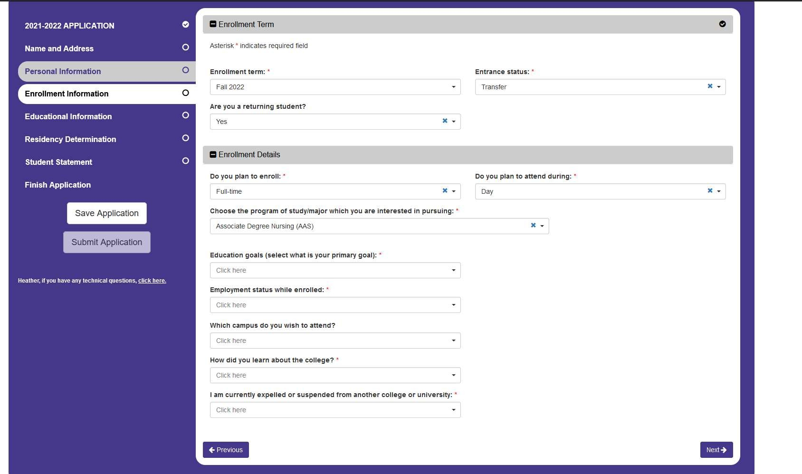

- The Nursing Program Director and the Admissions Director will then determine if the required GPA of 2.5 in the required nursing program courses have been met. Students must hold a cumulative GPA of 2.0 for all courses previously taken at SCC.

- Readmission to the nursing program will be on a space available basis. A student’s TEAS score may determine re-entrance if space is unavailable for all students attempting to reenter. For
example, if there are 5 available spaces for 7 students, the 5 students with highest TEAS scores will be offered seats. TEAS scores accepted are those taken at SCC only and must be within 2 years of restarting the program. The score must be obtained on the most up-to-date version of the TEAS.
- Students wishing to reenter into SCC's ADN program must:

  - Successfully complete selected skills competencies administered by the SCC nursing department, and

  - Successfully complete a written competency exam covering all transferable NUR courses.

A test breakdown of the written competency, a list of skills, any outstanding admission requirements, and instructions for scheduling the competency test will be emailed to the student by the ADN Program Director. Students will have one attempt to pass the competency exam and skills; otherwise, the student is ineligible for readmission to the Nursing program.
- Additional general admission requirements for the ADN program must be fulfilled and include:

- Completed physical exam (new)
- Immunization updates
- Criminal background check (new)
- Drug screening (new)
- CPR certification
- CNA1 certification (listed on the NC nurse aide Registry)

NOTE: Effective February 1, 2020 students from other nursing programs will need to start from the beginning of the program.

B. LPN-ADN Readmission Policy

Students seeking readmission into SCC’s LPN-ADN program must apply for readmission to the SCC Admissions Office and satisfy the initial program admission requirements.

Students will be permitted to reenter the LPN-ADN program no more than once.

Students seeking readmission who were formerly enrolled in the LPN-ADN program at SCC and wish to reenter within two years of exiting the program, must reenter the semester immediately following their last successful NUR class (example: if a student successfully completes NUR 214 and subsequently withdraws, the student must reenter the nursing program beginning the semester immediately following NUR 214). All nursing and general education courses required in the semesters preceding the intended point of reentry must be satisfactorily completed.

Students who enter SCCs LPN-ADN program after having withdrawn from the LPN-ADN program more than two years earlier will restart the program as a new student if only admitted once previously. NUR 117 (Pharmacology) will need to be repeated for credit to ensure safety of patient care.

SCC LPN-ADN Program does not accept advanced placement students from other institutions.

Steps:
  - Students seeking advanced standing status must first complete an application for the term (Fall, Spring) and year of reentrance. To qualify for readmission as advanced standing, an applicant must submit an intent application for advanced standing no later than 45 days prior to the intended start date.
  - The Admissions Director will determine if the required GPA of 2.5 in the required nursing program courses have been met. Courses within the program of study will be included up to the point of readmission. Students must hold a cumulative GPA of 2.0 for all courses previously taken at SCC.
  - Readmission to the nursing program will be on a space available basis. Qualified applicants will be accepted in relation to their ATI® PN Predictor Exam score. The ATI® PN Predictor scores accepted are those taken at SCC only and must be within 2 years of restarting the program. The score must be obtained on the most up-to-date version of the ATI® PN Predictor.
  - Students wishing to return to the LPN-ADN program as advanced standing have two options (1) The student may successfully complete a written competency exam covering all SCC NUR courses or (2) they may choose to audit the previous course and the test grade average will be used to determine if the student passes. The student must submit their choice in writing the first week of the course to the Associate Director of Nursing. After successful completion of the course, either by audit or competency, the student will successfully complete selected skills competencies administered by the LPN-ADN Clinical Coordinator.

Students only have one attempt to successfully pass the competency exam and skills competencies. If a student does not successfully pass the exam or skills on the first attempt, the student is ineligible for re-entrance into the program.

  - A complete physical is required. A blank medical form will be mailed to the applicant upon acceptance for readmission. All required immunizations must be current for full acceptance into the LPN-ADN program.
  - Applicants applying for readmission / advanced standing are required to complete a new criminal background check and drug screen.

  - Current certification in AHA Healthcare Provider CPR must be submitted prior to reenrollment.

  - If an otherwise qualified applicant is not accepted for readmission due to space limitations, the student must submit another application for readmission if the student wishes to be considered in a subsequent year.

Special Circumstances:
For applicants previously enrolled in SCC’s LPN-ADN program and who were withdrawn after having been unsuccessful in NUR 117 or NUR 221, the following will apply:

- Student who fails or withdraws from NUR 117 (Pharmacology) and successfully completes NUR 221 (LPN-ADN Concepts I):
  - May apply for advanced standing admission to the third semester of the LPN-ADN program and will follow the nursing guidelines for readmission including competency testing in NUR 214 and NUR 221.
  - Must successfully complete NUR 117 (Pharmacology) prior to readmission
- Student who fails or withdraws from NUR 221 (LPN-ADN Concepts I) and successfully completes NUR 117 (Pharmacology)
  - Must apply for advanced standing to the second semester of the LPN-ADN program.
  - Must successfully complete a competency exam for NUR 117 (Pharmacology) and NUR 214 prior to registering for NUR 221 (LPN-ADN Transition Concepts I).
- Student who fails NUR 117 and NUR 221:
  - Student must apply for advanced standing into NUR 221 and pass a competency for NUR 214 before retaking NUR 117 and NUR 221.

Criteria for Graduation:
To be eligible for graduation, a student must:
  - Successfully pass all course requirements in major with an overall major grade point average of 2.00 or higher.
  - Complete an application for graduation when registering for your last class.
  - Earn at least one-fourth of the credits required for a degree, diploma, or certificate from Stanly Community College.
  - Fulfill all financial obligations to the College.
  - Graduation exercises are held on the dates published in the Academic Calendar. During graduation exercise candidates must be dressed in proper academic attire as determined by the President of the College.

Pinning:
The Pinning Ceremony is a dignified event sanctioned by the nursing faculty and is planned and funded by the ADN club with guidance from the club advisor. It is a formal
ceremony for students to pay tribute to each other, family, friends, and faculty and a time for faculty to recognize students who have shown outstanding achievement and/or professional growth. The place, time, and date of the Pinning Ceremony are approved by the Program Director and the President of SCC. Guidelines are shared with the senior class by the nursing club advisor. Nursing faculty reserve the right to rescind this privilege at any time.

Licensure:
- The Program Director verifies a student with the North Carolina Board of Nursing as a candidate for the National Council Licensure Examination for Registered Nursing based on academic achievement and professional accountability following graduation.
- The North Carolina Board of Nursing may deny licensure to individuals convicted of a felony or any other crime involving moral turpitude.

STANLY COMMUNITY COLLEGE NURSING PROGRAM OF STUDY (GENERAL TRACK)

Summer prior to start of program
Class Lab Clinical Credit
HUM 115 Critical Thinking 3 0 0 3
1st FALL
Class Lab Clinical Credit
NUR 111 Intro to Health concepts |  | 4 | 6 | 6 | 8
BIO 168 Anatomy & Physiology I |  | 3 | 3 | 0 | 4
PSY 150 General Psychology |  | 3 | 0 | 0 | 3
ACA 122 College Transfer Success |  | 1 | 0 | 0 | 1
Total Hours |  |  |  |  | 16
1st SPRING – 1st 8 WEEKS
NUR 112 Health-Illness Concepts |  | 3 | 0 | 6 | 5
BIO 169 Anatomy & Physiology II |  | 3 | 3 | 0 | 4
PSY 241 Developmental Psychology |  | 3 | 0 | 0 | 3
NUR 117 Pharmacology |  | 1 | 3 | 0 | 2
1st SPRING – 2nd 8 WEEKS
NUR 212  NUR 117 | Health System Concepts  Pharmacology | 3  1 | 0  3 | 6  0 | 5  2
Total Hours |  |  |  |  | 19
SUMMER
NUR 113 | Family Health Concepts | 3 | 0 | 6 | 5
Total Hours |  |  |  |  | 5
2nd FALL – 1st 8 WEEKS
NUR 211 Health Care Concepts | 3 | 0 | 6 | 5
ENG 111 Expository Writing | 3 | 0 | 0 | 3
2nd FALL – 2nd 8 WEEKS
NUR 114 Acute Health Concepts | 3 | 0 | 6 | 5
Total Hours |  |  |  | 13
2nd SPRING
NUR 213 Complex Health Concepts | 4 | 3 | 15 | 10
ENG 112 Literature-Based Research  Or | 3 | 0 | 0 | 3
ENG 114 Prof. Research & Reporting  Total Hours |  |  |  | 16

TOTAL PROGRAM HOURS 69

STANLY COMMUNITY COLLEGE NURSING PROGRAM OF STUDY – (LPN to ADN TRACK)

Course Title Course Category Hours Per Week
Summer Semester Class Lab Exp Credit Hours

ACA-122 | College Student Success | Other |  | 2 | 0 | 0 | 1
BIO-169 | Anatomy and Physiology II | Other | 3 |  | 3 | 0 | 4
PSY-241 | Developmental Psychology | General | 3 |  | 0 | 0 | 3
NUR-214 | Nursing Transition Concepts | Major | 3 |  | 0 | 3 | 4
Total Hours |  |  |  |  |  |  | 12

Fall Semester
ENG 111 Expository Writing
NUR-221 LPN-ADN Concepts I

General Major
Class Lab Exp Credit Hours 3 0 0 3
6 0 9 9

NUR-117 Pharmacology Major 1 3 0 2
Total Hours 14
Spring Semester NUR-223
LPN-ADN Concepts II Major
ENG-112 Writing and Research in the Disciplines General
Class Lab Exp Credit Hours

6 | 0 | 9 | 9
3 | 0 | 0 | 3

ENG-114
OR
Professional Research & Reporting General 3 0 0 3
Humanities Elective General 3 0 0 3

Total Hours 15
TOTAL PROGRAM HOURS 41*
*Students admitted to the LPN-ADN track will be given a blanket number of transfer hours for successful completion of an LPN Program (30 hours).

Appendix i

STANLY COMMUNITY COLLEGE

Program Handbook Acknowledgement Form

I, the undersigned, have read, received an explanation of, and understand the Associate Degree Nursing (ADN) Program Student Handbook.

I also understand that I must comply with and follow these policies during the period of my enrollment as a nursing student at Stanly Community College.

Student Signature Date

Appendix ii

STANLY COMMUNITY COLLEGE

REMEDIAL SKILLS FORM

Date Issued:

The student, , needs remedial work in the following skill:

.

Remedial Objectives: The student will:

- Review the appropriate text for the procedure in performing the skill.

- Practice the skill in the lab.

- Demonstrate the skill to an Instructor in the lab.

- Achieve a satisfactory on the performance of the skill in the lab.

- Return the lower portion of this remedial work slip to the CLINICAL INSTRUCTOR who issued it.

- Complete the remedial objectives within ONE WEEK from the time it was issued.

Date Issued: Date Completed:

This student has successfully completed all the remedial objectives for the following skill:

Instructor’s Signature Date

Appendix iii

REPORT: UNSAFE INCIDENT IN THE CLINICAL SETTING

CRITICAL INCIDENT DEFINED:

An incident in the clinical setting involving a student in which:

- The conduct and/or performance of the student did or potentially did endanger client welfare.

- The incident could have been prevented by application of learning objectives previously covered.

DESCRIPTION OF INCIDENT (BY STAFF AND/OR INSTRUCTOR):

Date of Incident Location of Incident

Instructor Signature Date

PERCEPTION OF INCIDENT (BY THE STUDENT):

Student Signature Date

Appendix iv
CLINICAL PROBATION REMEDIATION PLAN

A student may receive an “Unsatisfactory” evaluation in clinical for reasons which include, but are not limited to, the following:
- less than satisfactory clinical performance
- unsatisfactory written assignments
- medication errors and/or performing any procedure or giving any medication without securing appropriate supervision designated by the instructor.
- HIPAA violation
- late assignments
- lack of professional behavior

A student who earns 2 “U” evaluations during the semester will automatically be placed on clinical probation, and remediation will be instituted. The student will meet with the Course Coordinator or Clinical Coordinator, and remediation will be determined. Any remedial work must be completed at a date determined by the Clinical Coordinator. There will be scheduled advising throughout the probation period between the student and the Course Coordinator or Clinical Coordinator.

The student will be removed from clinical probation when satisfactory clinical performance is exhibited as evaluated by the clinical instructor and the Clinical Coordinator.

Any additional “U” evaluation – (during the current semester or during the probation period if it extends into the following semester) – received during clinical or for not completing remediation as directed by the faculty, will constitute a Failing (F) grade for clinical. The student will be dropped from the program at that point and receive a failing grade for the semester in that nursing course. The student whose probationary period extends into the next semester will receive an Incomplete (I) grade and will have a specified date given by the course coordinator to complete the remediation or receive an “F” for the course.

Terms of Clinical Probation and Clinical Remediation Plan for student:

Timeline of unsatisfactory clinical events with dates:

Clinical Remediation Plan and Due Date with time:

Failure to successfully complete this clinical probation/remediation plan will result in not being able to return to the clinical site, inhibiting progression in the nursing program.

STANLY COMMUNITY COLLEGE
Appendix v

HEPATITIS B VACCINE – DECLINATION FORM

HEPATITIS: Hepatitis is a liver disease, initially resulting in possible inflammation of the liver, and frequently leading to more serious conditions including cirrhosis and liver cancer. In the United States, there are approximately 300,000 new cases of Hepatitis B Virus (HBV), the most prevalent form of Hepatitis, every year. While there is no cure for Hepatitis B, a vaccine does exist that can prevent infection.

HBV is most often transmitted through breaks in the skin or mucous membranes. This usually occurs through needlesticks, human bites, or having infectious material (such as blood or other body fluids) get into existing cuts or abrasions.

The symptoms of HBV infection are very much like a mild “flu”. Initially, there is a sense of fatigue, possible stomach pain, loss of appetite, and even nausea. As the disease continues to develop, jaundice (a distinct yellowing of the skin) and a darkened urine will often occur. However, people who are infected with HBV will often show no symptoms for some time.

After exposure, it can take 2 - 6 months for Hepatitis B to develop. This is extremely important, since vaccinations begun immediately after exposure to the virus can often prevent infection.

After completing the series of three immunizations, the Hepatitis B vaccine provides protection by building up a sufficient level of antibodies. The vaccine is specific to Hepatitis B and is not effective against other types of hepatitis nor does it protect against the HIV or AIDS virus.

If you feel that your work activities place you at risk for Hepatitis B, please consider the following before taking the vaccine.

You Should Not Take The Vaccine…
- If you have an allergy to yeast.
- If you are pregnant or nursing.
- If you are planning to become pregnant within the next six months.
- If you have had a fever, gastric symptoms, respiratory symptoms, or other signs of illness in the last 48 hours.
You may want to consult your own physician before taking the vaccine.

I, have been given the opportunity to receive the Hepatitis B vaccine series. I have read the Important Information About Hepatitis B and Hepatitis B Vaccine sheet and understand I am at risk of contracting Hepatitis B due to my student related activities. I have been given the opportunity to ask questions and understand the risk factors involved. Understanding the risk factors involved, I refuse to receive the Hepatitis B vaccine series. I hereby release Stanly Community College from responsibility for consequences of not receiving the vaccine.

Signature Date

Appendix vi

Simulation Guidelines
To preserve the function and quality of the equipment and enable future students to benefit from the simulation exercises at Stanly Community College, all participants of simulation agree to abide by the following guidelines:
- Manikins are to be treated as if they are real, live patients.
- Positive, professional communication with faculty instructors, students and other users shall be maintained.
- Faculty, staff, and students must complete orientation prior to using the equipment.
- Doors of the simulation hospital will be locked at all times.
- Instructors and students must sign-in and out on the attendance roster.
- Instructors should remain with students while participating in simulation.
- No food or drink is permitted.
- Personal belongings should be minimal into simulated patient care areas.
- No cell phones should be operational around manikins.
- Do not sit on the beds; this is considered the patient’s personal space.
- No ink pens should be used within close proximity of the manikins.
- Manikins should not be removed from their beds.
- Students should not change parts on manikins.
- Students should not perform any procedures on manikins without the instructor’s approval.
- Injections and IV sticks are prohibited on the manikins.
- No betadine, acetone, iodine, or other staining fluids should be used on the skin of the manikins.
- All equipment will be returned to proper stations after use.
- All beds should be made neatly and returned to their lowest position.
- Do not use simulated equipment other than its intended use.
- Report any damages to the proper individuals.

Anyone abusing simulated equipment will be asked to leave and may be held responsible for broken or missing equipment.
Initials

Appendix vii.

SCC Simulation Professional Integrity Agreement
Stanly Community College follows best practice guidelines set forth by the International Association for Clinical Simulation and Learning (INACSL) Standards of Best Practice: Simulation (SM). The standard of Professional Integrity states, “Professional integrity is demonstrated and upheld by all involved in simulation-based experiences” (INACSL, 2016). The criteria necessary to meet this standard include:
  - Foster and role model attributes of professional integrity at all times.
  - Follow standards of practice, guidelines, principles, and ethics of one's profession.
  - Create and maintain a safe learning environment.
  - Require confidentiality of the performances and scenario content based on institution policy and procedures.

Below is the professional integrity agreement and rules of simulation that must be followed in accordance with INACSL Standards of Best Practice: Simulation

Professional Integrity Agreement
Simulation activities at SCC include clinical scenarios, simulated task training, simulated patient scenarios, debriefings, and discussions. As a student involved in simulation as a clinical learning experience, you are expected to engage and fully participate as a professional and treat each case as a realistic patient scenario. Therefore, the Health Insurance Portability and Accountability Act (HIPAA) requirements apply with regard to confidentiality of the scenarios. HIPAA regulations apply to all clinical experiences including electronic, written, verbal, or observed, and may not be discussed outside the simulation environment. Any violation to this agreement including sharing, posting to social media, discussion, recording, reproducing, or revealing any part of the simulation activity will results in an “unsatisfactory” in clinical performance, which will result in unsatisfactory on the end- of-semester clinical summary, leading to failure to progress in the program.

Your signature below acknowledges that you have read, consent to, and fully understand the implications of this agreement, the guidelines for use of the lab (on the back of this sheet), and will follow each during all simulation activities.

Print Name

Student Signature _

Date

Appendix viii.
STANLY COMMUNITY COLLEGE
MEDICAL RELEASE FORM

To Whom It May Concern: _________________________________ is under my medical care.
(Student’s Name)

All applicable instructional areas must be addressed:

Limitations/Comments: ____________________________________________________________________________________________________
Primary Care Provider’s Signature: __________________________________________________
Primary Care Provider’s Printed Name: __________________________________________________
Date: _____________________________________________________________________________
Reason for visit: ________________________________________________________________
FOR COLLEGE USE ONLY
Authorization for student to return: Approved – allowed to return to program on: ______________________

Program Director/Faculty Signature: ________________________________________________ Date: _________________________
Comments: ___________________________________________________________________________________________________
_____________________________________________________________________________________________________________
_____________________________________________________________________________________________________________
_____________________________________________________________________________________________________________

